Data Communication Project
Network Game
“4 in 1 Row”

Submitted By:
Nassim Zaher ID: 066412149

This project is a network game “4 in one Row “the project has two servers and 2 client(s) interfaces

Design Diagram

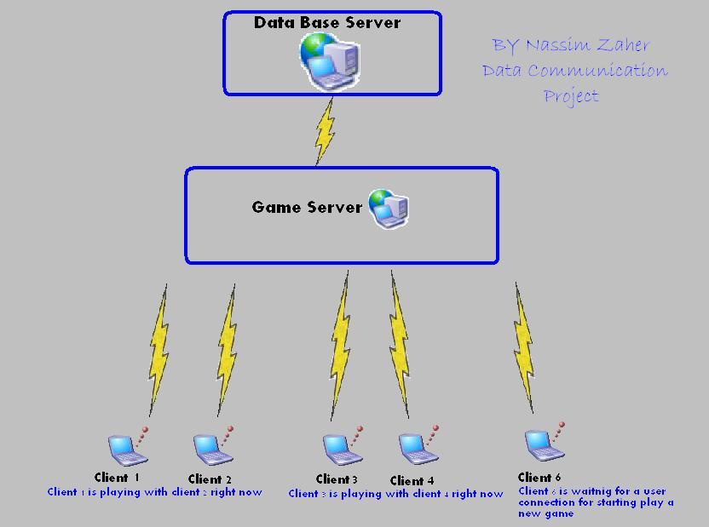

Servers:
- Data Base Server.
- Game Server.
Clients:
- Game Server Client (Admin).
Need a password to Enter the Admin Interface, the password: “Admin”
- User interface “player”.

I will explain the principle of the project then I will explain all about the servers and clients side.
All of the clients have a user name & password it used for logon and starting playing or for report about his self about status about his rank …
In the first logon of the user he should register a new user name and password.
First step: click 1 for register then enter a user name, password and email
Then you will receive an answer if all is OK.

For example : 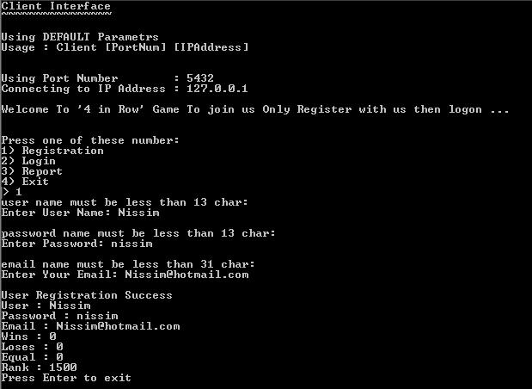

Then you have to logon and wait until someone else “user” logon and the game server connect the user to the table to start playing the first player Vs the second
For example:
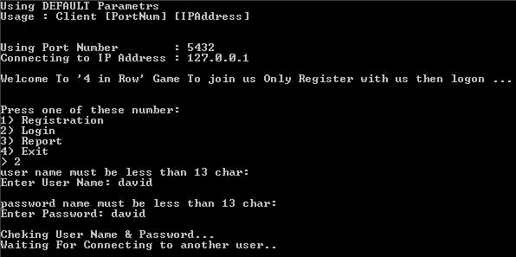

And when the second player connect to the table the game will start and the first one who connected to the table he will start insertion
For example:
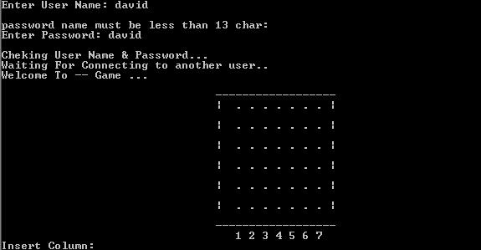

But the second player can’t see the “Insert Column:” text and he can't insert any character or do anything until the first player will insert and sending him the insertion location.

For example:
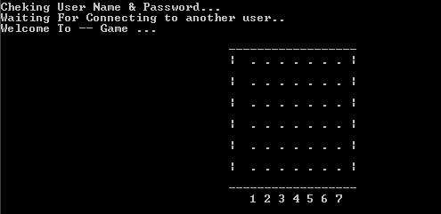

Then the game will start and the players will start to insert the icons until someone will win or the box will be filled and the result will be TEKO☺.
And the game server will update the results on the Data Base Server….

About the Game Server Client “Admin”:
The game server client does for the admin only … it can remove a user or report a user .. and it didn’t need the password of the user for remove him or report…

For example:
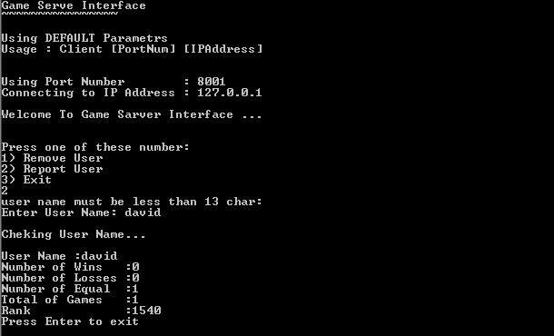
And the two server :
Game server :
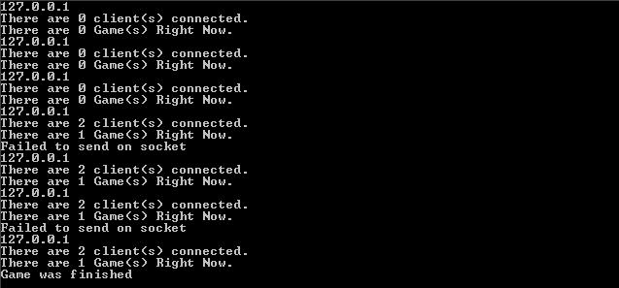

Data Base Server:
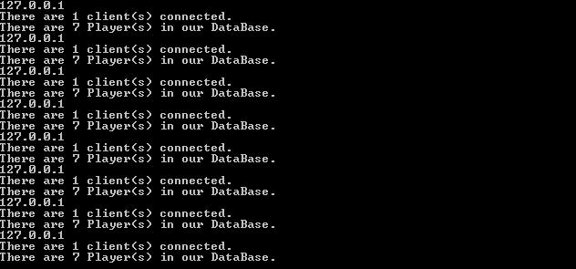

This about how to use all of the interfaces….

Implementation:

Data Base Server:
The data server has the
main.cpp: in the begging and the end of the main code there are two functions:
1) load from file function
2) save to file function
the load function called in the first roe of the code but the save function called every time the game server connect to the data base server because if there are some updates so save it to the files…

Then the data base server has the class Players “every player allocated for him one class and pushed to the list”
The player class had 8 important variables:
string user; // his username
string password; //his password
string email;//his email
int wins;// how many wins he has
int loses; // how many losses he has
int equal; // how many equal he has
int rank; // the rank
Busy_e status; //his status if he playing right now or not
When the Data base have a connection from the games server the data base create a thread and calling the
int WorkerThread::Process() {….} function
Then in this function the the game server send by the socket
For example: “m_socket->recv(buf,sizeof(Registration)); “
The option what_to_do
  - to register a new user
  - logon
  - report
  - update
  - remove
  - Report “only for game server client “admin “.

And the Data Base server returns with the reply massage that contains what he has to send….

Game Server:
the game server waiting for incoming connection from the player “client(s)” and when occurred a connection the game server checking the connection for registration or logon or…
then game server check the user name and password and return to the user with the reply massage..
and if the massage is ok for logon the game server sending the user name for the Table Manager Class and the table manager will manage the Table Class for opening a new table or adding a user to table and when the table starts the table will be the manager of the players and the table will update the Data Base Server
the Table Manager has :
//save the Tables
std::list<Table *> Table_list; //save the Tables
list of the tables…

And there are another two classes, the Game Class and the Player Class
The Game Class: it has the game!! And in this class checking if the game was finished or if the result is TEKO or some one win…. And return the answer to the Table
The Players Class: it has the player username and the a Socket Pointer to send and receive a messages from the table …
StreamSocket* socket_t;// socket of the player
string username; // username of the player

Then when the game starts the Table Manager create a thread “class Table: public Thread create a table “ and the game will start with the process

Client “Player” :
The client has the main.cpp & Game.cpp :
The game.cpp has the game and the insertion icon and the legality of the game
the main.cpp has the most of the code has the registrations and the logon and the report and all of these things …

Game Server Client “Admin” :
In this workspace we have the same things like the client for the report massages but the different are two things
- In this workspace we have one function that only the admin has it “ REMOVE UESER”
- To remover user or report user shouldn’t need the password of the users.

